**14. Explain some of the most used Spring Boot annotations**

* ***@SpringBootApplication****:* Used to denote a class as Spring Boot application, it contains features of three annotations listed.

@SpringBootApplication = +

* ***@Configuration***: Used to declare a class as a configuration setting for bean definitions.
* ***@Component***: Used to mark the class as Spring bean and its management is handled by Spring container.
* ***@Autowired:***It injects the required dependencies into a bean automatically.
* ***@RestController:*** Used to denote a class as a REST controller.

@RestController = @ResponseBody + @Controller

* ***@Bean:***Used for the creation of beans and registering them with the Spring container for auto management.

**15. Explain the internal working of *@SpringBootApplication***

The *@SpringBootApplication* annotation performs several tasks as it contains features of three annotation will are *@Configuration*, *@EnableAutoConfiguration*, and *@ComponentScan.*

* *@SpringBootApplication* enables component scanning for beans and auto-configuration.
* Registers various beans, including Spring Boot auto-configuration beans.
* Instantiates the embedded server
* Runs the application

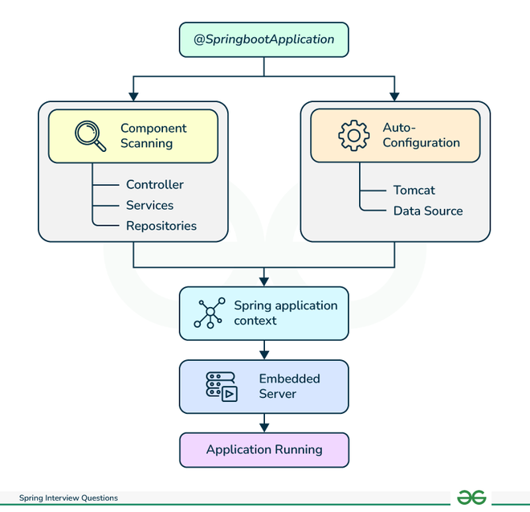

**16. Explain types of configuration in Spring Boot**

Spring Boot uses a layered approach to configuration:

* **Default configuration:** Defaults configuration with available libraries and dependencies.
* **Custom configuration:** It can override default configuration through
  + properties files
  + environment variables
  + annotations
* **External configuration:** import configuration from external sources like
  + Git repositories
  + cloud platforms

**19. What is an Actuator and its usage in Spring Boot**

Spring Boot Actuator provides a RESTful API for monitoring and managing Spring Boot applications. These endpoints provide information about applications that can be used to optimize resources and debug issues, including:

* Environment variables
* Thread dumps
* Health checks
* Metrics
* Beans
* Logs

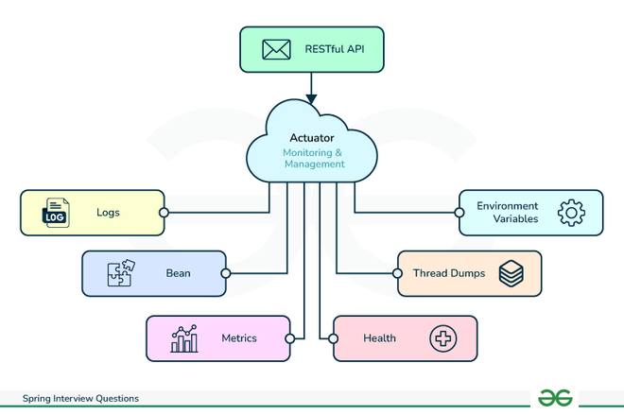

Q: what annotations are available in @SpringBoot Application? What all processes are embedded in it?

Q: how would be exclude some packages or classes when spring boot application loads?

Q: diff between setter injection and constructor injection?

Q: what is stubbing?

Q @component vs @bean

Q: @conditional